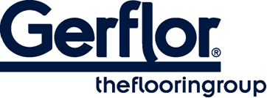 MURAL CALYPSO

MURAL CALYPSO is a multilayered wall covering in 2m width roll and with a B-s2,d0 fire classification.

It is hot welded with CR41 welding rods.

It is made of a printed transparent wear layer and a coloured under layer for an easier welding of the product. This layer comprises 20% of recycled products.
It does not contain any CMR 1 & 2 component and is 100% compliant with REACH.
It is 100% recyclable.

